Decorator Pattern

A Decorator Pattern says that just **"attach a flexible additional responsibilities to an object dynamically".**

In other words, The Decorator Pattern uses composition instead of inheritance to extend the functionality of an object at runtime.

The Decorator Pattern is also known as **Wrapper.**

Advantage of Decorator Pattern

* It provides greater flexibility than static inheritance.
* It enhances the extensibility of the object, because changes are made by coding new classes.
* It simplifies the coding by allowing you to develop a series of functionality from targeted classes instead of coding all of the behavior into the object.

Usage of Decorator Pattern

* When you want to transparently and dynamically add responsibilities to objects without affecting other objects.
* When you want to add responsibilities to an object that you may want to change in future.
* Extending functionality by sub-classing is no longer practical.

UML for Decorator Pattern:

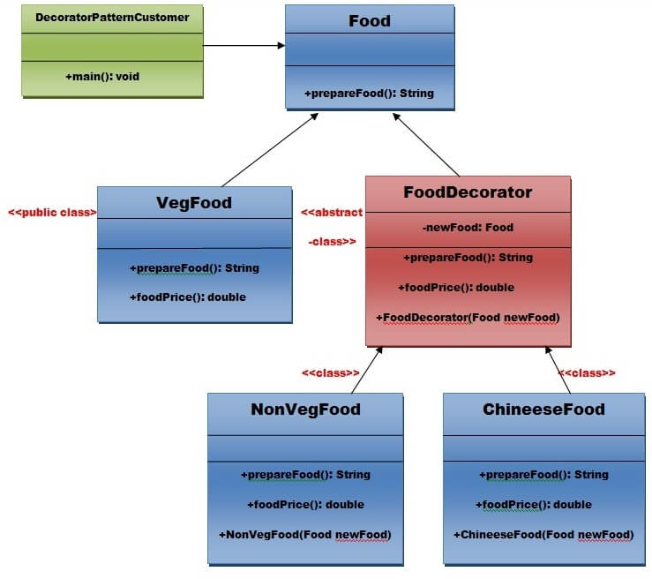

Step 1:**Create a Food interface.**

1. **public** **interface** Food {
2. **public** String prepareFood();
3. **public** **double** foodPrice();
4. }// End of the Food interface.

Step 2: Create a **VegFood** class that will implements the **Food** interface and override its all methods.

*File: VegFood.java*

1. **public** **class** VegFood **implements** Food {
2. **public** String prepareFood(){
3. **return** "Veg Food";
4. }
6. **public** **double** foodPrice(){
7. **return** 50.0;
8. }
9. }

Step 3:Create a FoodDecorator abstract class that will implements the Food interface and override it's all methods and it has the ability to decorate some more foods.

*File: FoodDecorator.java*

1. **public** **abstract** **class** FoodDecorator **implements** Food{
2. **private** Food newFood;
3. **public** FoodDecorator(Food newFood)  {
4. **this**.newFood=newFood;
5. }
6. @Override
7. **public** String prepareFood(){
8. **return** newFood.prepareFood();
9. }
10. **public** **double** foodPrice(){
11. **return** newFood.foodPrice();
12. }
13. }

Step 4:Create a **NonVegFood concrete** class that will extend the **FoodDecorator** class and override it's all methods.

*File: NonVegFood.java*

1. **public** **class** NonVegFood **extends** FoodDecorator{
2. **public** NonVegFood(Food newFood) {
3. **super**(newFood);
4. }
5. **public** String prepareFood(){
6. **return** **super**.prepareFood() +" With Roasted Chiken and Chiken Curry  ";
7. }
8. **public** **double** foodPrice()   {
9. **return** **super**.foodPrice()+150.0;
10. }
11. }

Step 5:Create a **ChineeseFood** concrete class that will extend the **FoodDecorator** class and override it's all methods.

*File: ChineeseFood.java*

1. **public** **class** ChineeseFood **extends** FoodDecorator{
2. **public** ChineeseFood(Food newFood)    {
3. **super**(newFood);
4. }
5. **public** String prepareFood(){
6. **return** **super**.prepareFood() +" With Fried Rice and Manchurian  ";
7. }
8. **public** **double** foodPrice()   {
9. **return** **super**.foodPrice()+65.0;
10. }
11. }

Step 6:Create a **DecoratorPatternCustomer** class that will use Food interface to use which type of food customer wants means (Decorates).

*File: DecoratorPatternCustomer.java*

1. **import** java.io.BufferedReader;
2. **import** java.io.IOException;
3. **import** java.io.InputStreamReader;
4. **public** **class** DecoratorPatternCustomer {
5. **private** **static** **int**  choice;
6. **public** **static** **void** main(String args[]) **throws** NumberFormatException, IOException    {
7. **do**{
8. System.out.print("========= Food Menu ============ \n");
9. System.out.print("            1. Vegetarian Food.   \n");
10. System.out.print("            2. Non-Vegetarian Food.\n");
11. System.out.print("            3. Chineese Food.         \n");
12. System.out.print("            4. Exit                        \n");
13. System.out.print("Enter your choice: ");
14. BufferedReader br=**new** BufferedReader(**new** InputStreamReader(System.in));
15. choice=Integer.parseInt(br.readLine());
16. **switch** (choice) {
17. **case** 1:{
18. VegFood vf=**new** VegFood();
19. System.out.println(vf.prepareFood());
20. System.out.println( vf.foodPrice());
21. }
22. **break**;
24. **case** 2:{
25. Food f1=**new** NonVegFood((Food) **new** VegFood());
26. System.out.println(f1.prepareFood());
27. System.out.println( f1.foodPrice());
28. }
29. **break**;
30. **case** 3:{
31. Food f2=**new** ChineeseFood((Food) **new** VegFood());
32. System.out.println(f2.prepareFood());
33. System.out.println( f2.foodPrice());
34. }
35. **break**;
37. **default**:{
38. System.out.println("Other than these no food available");
39. }
40. **return**;
41. }//end of switch
43. }**while**(choice!=4);
44. }
45. }

[download this Decorator Pattern Example](https://www.javatpoint.com/designpattern/designpatternexample/decoratorpattern.zip)

Output

1. ========= Food Menu ============
2. 1. Vegetarian Food.
3. 2. Non-Vegetarian Food.
4. 3. Chineese Food.
5. 4. Exit
6. Enter your choice: 1
7. Veg Food
8. 50.0
9. ========= Food Menu ============
10. 1. Vegetarian Food.
11. 2. Non-Vegetarian Food.
12. 3. Chineese Food.
13. 4. Exit
14. Enter your choice: 2
15. Veg Food With Roasted Chiken and Chiken Curry
16. 200.0
17. ========= Food Menu ============
18. 1. Vegetarian Food.
19. 2. Non-Vegetarian Food.
20. 3. Chineese Food.
21. 4. Exit
22. Enter your choice: 3
23. Veg Food With Fried Rice and Manchurian
24. 115.0
25. ========= Food Menu ============
26. 1. Vegetarian Food.
27. 2. Non-Vegetarian Food.
28. 3. Chineese Food.
29. 4. Exit
30. Enter your choice: 4